**Chadwick Boseman**

*Drew Miles and Samantha Sawyer*

*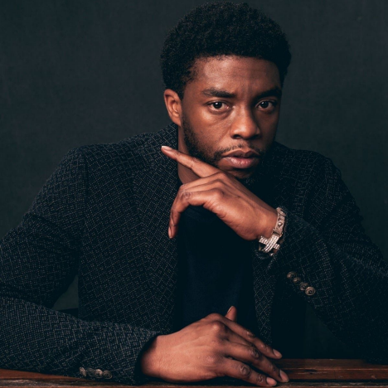Chadwick Boseman Photograph: By Andrew H Walker; Variety Magazine*

Chadwick Boseman’s career was so powerful because he chose roles that empowered the Black community. Throughout his acting journey he received six awards, five of which were for *Black Panther*, and acquired fifteen nominations. His significant legacy was not by chance. In an interview, he stated that there were several opportunities for him to accept roles that reinforced

stereotypes; he declined them in exchange for roles that illuminated a more valuable portrayal of Black history, culture, and truth. *Black Panther*, *42*, and *Get On Up* were exactly that. He spoke of his motivations for taking these roles stating, “Do not seek approval from the audience...You

have to live in the truth.” Chadwick is a legend that inspires creatives to use art wisely and honestly. Creators are destined to create, and Chadwick Boseman created a path for Black stories to be told visually.

*Quote: “I'm an artist. Artists don't need permission to work.” - Chadwick Boseman* Despite being diagnosed with stage 3 colon cancer in 2016, Chadwick used his art to inspire others. Boseman chose to fight and give his remaining years to the fans he adored. While enduring chemotherapy, multiple surgeries, and the eyes of the public, he delivered and starred in seven films over the course of four years. He possessed and maintained a regality on and off screen that left millions in awe, including his peers. “He set the bar high by working with a generosity of spirit, creating an ego free environment by sheer example,” said Lupita Nyong’o, Boseman’s friend and colleague. Now that he has passed, the world remembers him for the heroes he’s played on the screen and the hero he was in real life.

*Quote: “You have to cherish things in a different way when you know the clock is ticking...” - Chadwick Boseman*